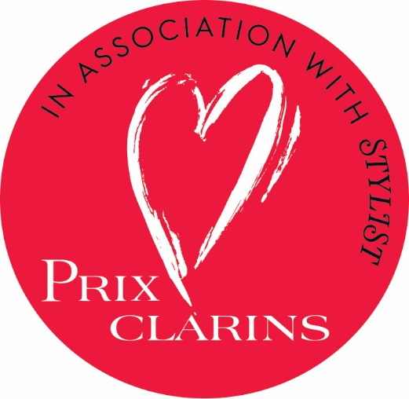

in Association with


Prix Clarins, in association with Stylist, seeks to recognise one inspirational woman who is improving the lives of the next generation and beyond through an innovative charity or initiative that she has founded. The winner of this prestigious award will receive £30,000 towards her project, plus bespoke mentoring sessions from Clarins and Stylist to equip her for the next phase of development. The prize, along with a commemorative trophy, will be awarded at an exclusive ceremony in central London, and accompanied by a feature on the winner in Stylist magazine.

What we’re looking for:

- The judges are looking for a woman who through her own charitable endeavour, is improving life for the younger generation; whether helping them to overcome challenges, navigate obstacles, increase their opportunities or supporting them in distressing circumstances.

- The judges are also looking for projects that are dedicated to finding long term solutions for those they are working with.

- Applicants must be a female British citizen. Although her work can be conducted anywhere in the world she must be available to attend an interview and the award ceremony in London if shortlisted.

Please complete the following in full including a recent headshot and email to prix.award@clarins.com. All applications must reach us by Wednesday 28th March 2018.

Nominee’s name:

Nominated by (you may nominate yourself):

Nominee’s Date of Birth:

Nominee’s contact address:

Postcode:
Email address:
Daytime telephone number:
Charity that nominee works for (include website and UK Charity Number, if charity is registered):

Nominee’s position at charity:

Year charity or initiative was established:

Please answer the following questions:

- Please describe the charity or initiative in no more than 300 words, explaining the overall vision – why it was established, who it serves, and its main objectives.

- Please describe in 300 words or less how the charity or initiative improves the lives of the next generation on both an everyday and long-term basis.

- Please give a brief insight (under 300 words) in to the initiative’s current five-year vision.

- Please give five qualities of the nominee – both personal and professional – which you believe makes them a worthy winner of Prix Clarins.

- In 300 words or less, please give a vision for how the prize money might be used, outlining the impact it could have on your project

- Has the nominee ever won or been shortlisted for any awards before? If so, please state below.

By signing this form you declare that to the best of your knowledge and belief, the information is true, correct and complete, and if nominating someone else, that they have consented to the application.

Full Name………………………Signature………………………………..Date………………….

All applications must reach us by Wednesday 28th March 2018

Shortlisted nominees will be notified by Monday 30th April 2018 and will need to be available for an interview in London in May 2018.

PRIX CLARINS IN ASSOCIATION WITH STYLIST: TERMS AND CONDITIONS

About the Award:
The award is being organised by Clarins UK Ltd, 10 Cavendish Place, London, W1G 9DN in association with Stylist, Shortlist Media 26-34 Emerald Street, London, WC1N 3QA. The award seeks to recognise a woman who through her own charitable endeavour, is improving life for the younger generation; whether helping them to overcome challenges, navigate obstacles, increase their opportunities or supporting them in distressing circumstances. The judges are also looking for projects that are dedicated to finding long term solutions for those they are working with.
How to enter:
To enter, visit www.clarins.co.uk/prix-clarins and complete an application form. Readers can either enter themselves or nominate someone they know.
The prize is as follows:
There will be one winner of UK Prix Clarins 2018. The winner will receive £30,000 towards their charitable project along with a commemorative trophy. The winner will also be the subject of a feature in Stylist magazine as well as receive mentoring from the Clarins and Stylist teams to equip them in progressing their charity further. The winner agrees to be available for an award ceremony in London on or around Tuesday 26th June 2018.
Eligibility:
Entrants must agree to their nomination and thereby agree to abide by the entry rules.
Entrants must have her own charitable endeavour, which is improving life for the younger generation; whether helping them to overcome challenges, navigate obstacles, increase their opportunities or supporting them in distressing circumstances.
Entrants must be female, over 18, and UK citizens, however their charitable endeavour may take place anywhere in the world.
Shortlisted applicants must be available for interview with the judging panel in central London, with two weeks’ notice.
The winner agrees to be available for further publicity, including a shoot and interview with Stylist, and to participate in next year’s awards, either as a judge or mentor.
Terms & Conditions:
Entries will be shortlisted by Stylist and Clarins whose decision will be final. All entries must be submitted by Wednesday 28th March 2018.
Shortlisted candidates will then be asked to attend an interview with a judging panel in London in May 2018 (exact date of the interview to be confirmed to candidates with two weeks' notice).
The winner of the award will be determined by the judging panel whose decision will be final and will be announced in early June 2018 or before.
Entries from both registered and non-registered charities will be accepted. In the case of a registered charity winner, the £30,000 prize money will be paid directly to the winner’s charity. If the winner is from a non-registered charity, references with telephone numbers must be provided with their nomination and the money will be held in trust by Clarins and issued against specific activities that the winner would like to implement for the charity within the year.
The winner will be required to sign a contract on handover of prize money.
Travel expenses will be recompensed for shortlisted candidates on provision of receipts, up to a maximum of £100. Candidates residing outside the UK due to the nature of their charity work would be interviewed via Skype but must be available to attend the award ceremony in London.
The award ceremony in London is scheduled to take place on Tuesday 26th June 2018. Stylist and Clarins reserve the right to change the date of the award ceremony and if so required, such change to be communicated to the winner with at least two weeks' notice.
There is no prize alternative.
Standard Shortlist Media rules apply.
Employees of Shortlist Media, Clarins and their families or households, or anyone else connected with this award are not eligible to enter.

